**Project part 4b**

1)

An ENUM is a string object that has a value selected from a set of acceptable values that are expressly listed in the column specification at the time the table is created. A unique data type called an enum allows a variable to represent a collection of specified constants. The variable must match one of the previously established value.

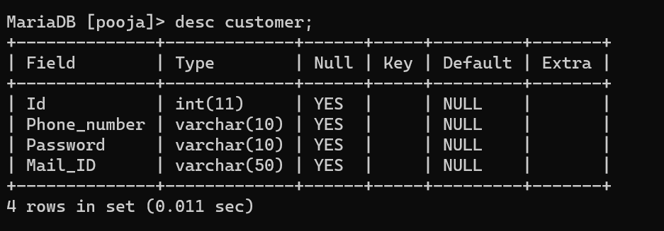

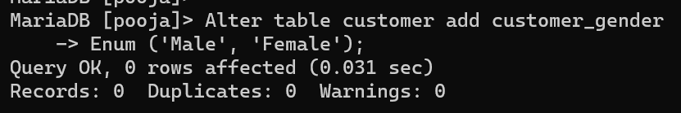

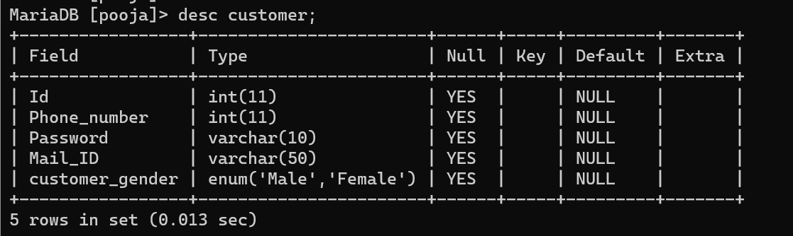

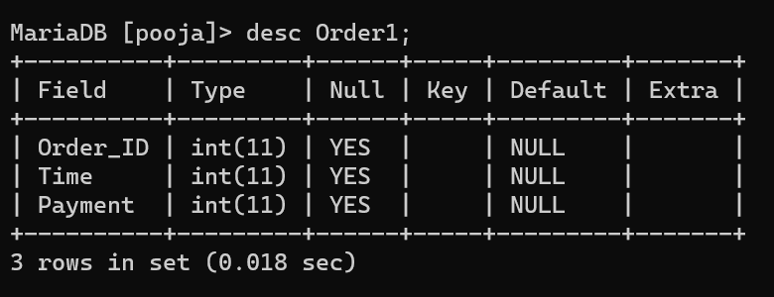

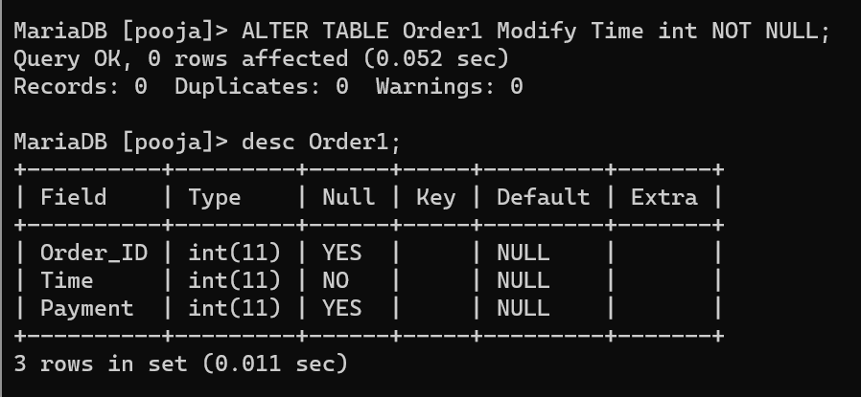

2)

a)

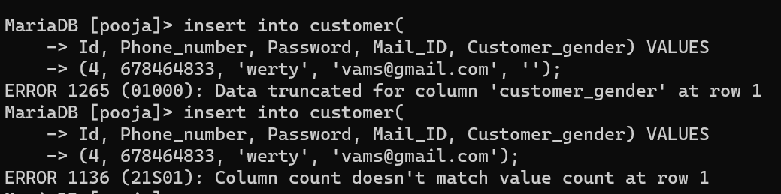

b)

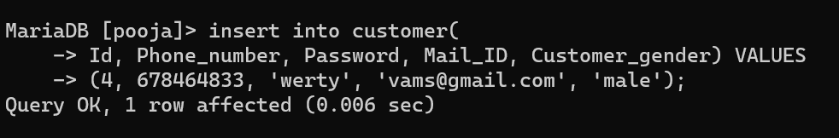

3)

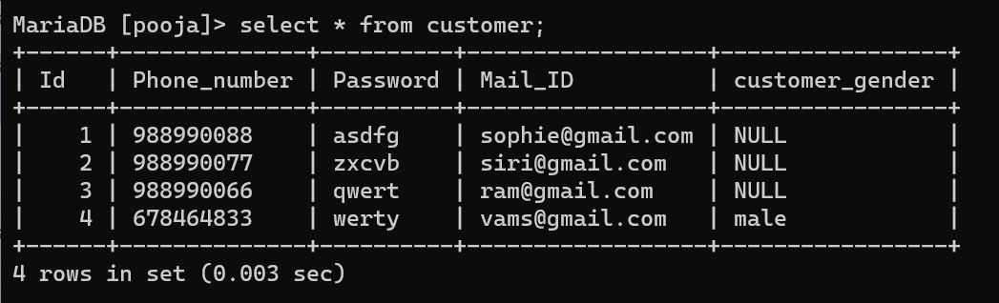

As I have stated customer_gender enum column, I have create the row for id = 4 with all the values.

Now I am updating the remaining null values in customer_gender column.

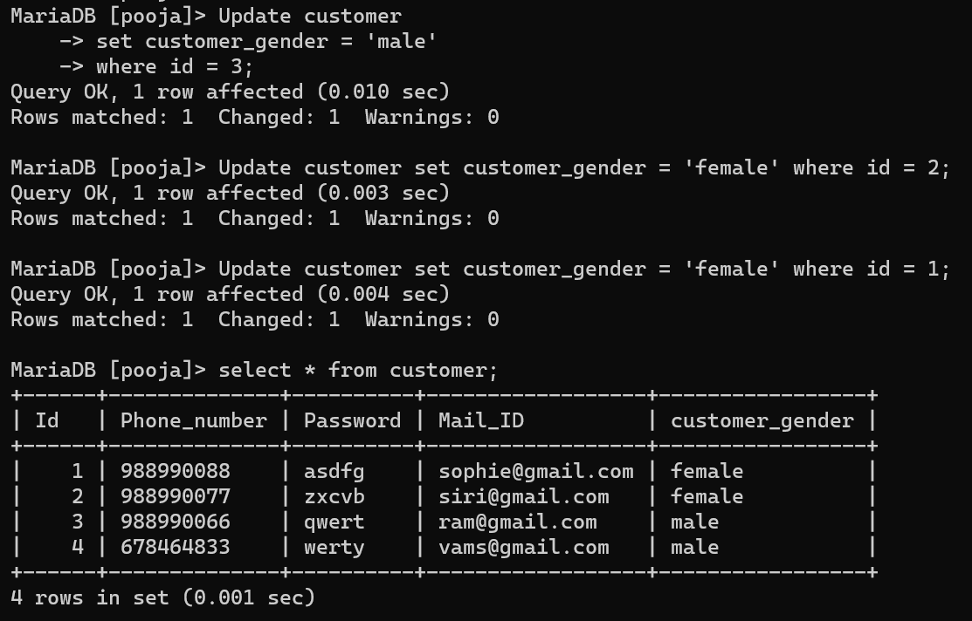

4)

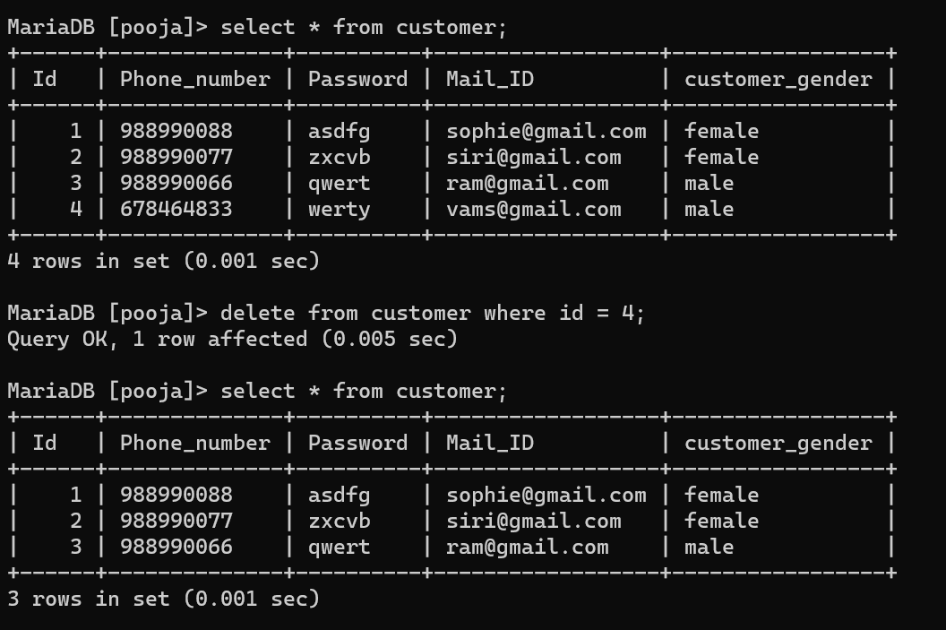

5)

To create an exclusive identity for new rows, utilise the AUTO INCREMENT property. If the auto increment column is NULL or DEFAULT (in the case of an INSERT), the value will automatically be increased whenever a new record is inserted into the table (or if an AUTO INCREMENT attribute is added with the ALTER TABLE command).

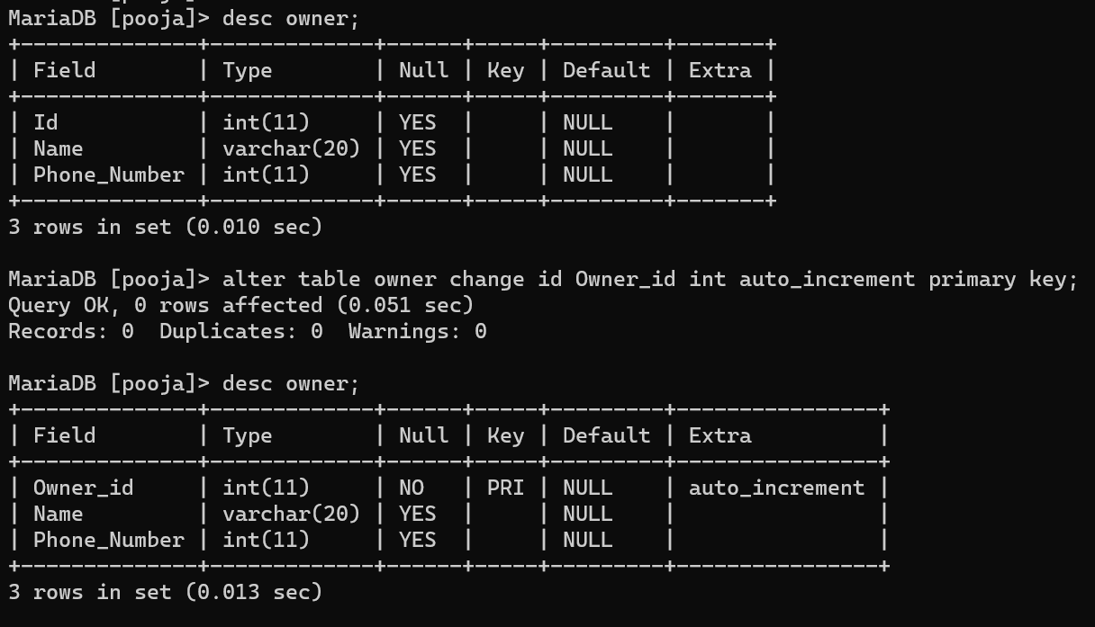

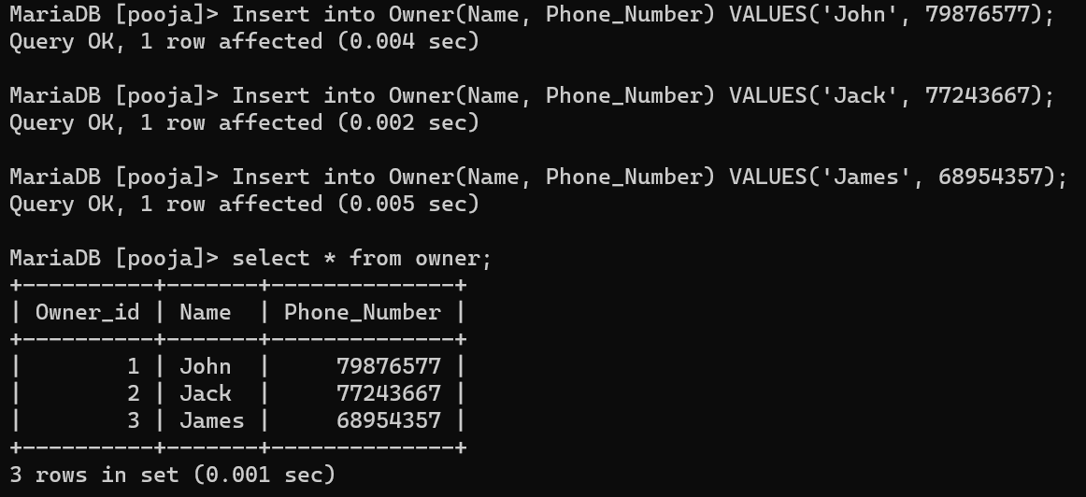

6)

A column can have a fixed default value by using the DEFAULT constraint. If no additional value is specified, the value will be appended to all new records. Dropping the default constraint only applies to new rows; it has no effect on the data already present in the table.

